**Assignment -4**

Python Programming

|  |  |
| --- | --- |
| Assignment Date | 20/10/22 |
| Student Name | Booshitha.M |
| Student Roll Number | 820319106004 |
| Maximum Marks | 2marks |

**Question 1:**

**Import the necessary libraries**

**Solution:**

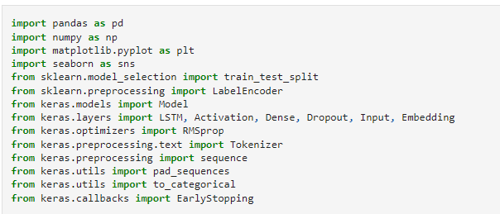

**Question 2:**

**Download the Dataset**

**Solution:**

Dataset Downloaded and uploaded to drive <https://www.kaggle.com/code/kredy10/simple-lstm-for-text-classification/data>

**Question 3:**

**Read dataset and do pre-processing**

**Solution:**

Read dataset

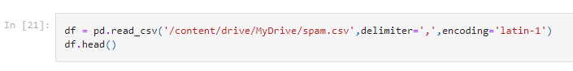

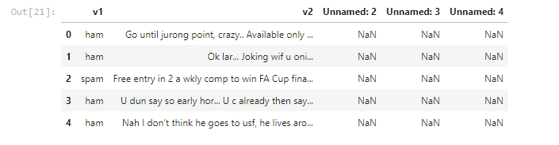

Pre-processing the Dataset

